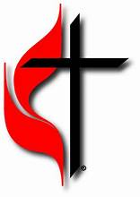 GRACE 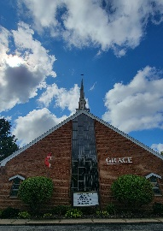

UNITED METHODIST CHURCH

1345 CHARTRES STREET, LaSalle, IL 61301

175th Anniversary

Worship Service

**SUNDAY, 21 SEPTEMBER 2025 AT 9 AM**

**SERMON: THE REV. CHRISTIAN COON**

***DIRECTOR OF CONGREGATIONAL DEVELOPMENT, UMCNIC***

**IN THE PRESENCE OF OTHER MINISTERS AND PASTORS.**

**PASTOR: Rev. Dr. Solomon Sudhakar**

**PLEASE JOIN US FOR FELLOWSHIP AND CAKE FOLLOWING SERVICE IN FELLOWS HALL.**